**PART A**

(Part A: TO BE REFERRED BY STUDENTS)

**Experiment No. 03**

**A.1 AIM:**

Study of Basic HTML tags & create a web page or website using HTML tags.

**A.2 Pre requisite:**

Basic Knowledge of HTML and HTML tags.

**A.3 Outcome:**

After successful completion of this experiment students will be able to:

1. Design pages in HTML
2. Perform all formatting of text and images in HTML
3. Create tables and lists in HTML
4. Design interactive pages in HTML using Frames
5. Use various properties of Frames

**A.4 Theory:**

**What is HTML?**

HTML is a language for describing web pages. HTML stands for Hyper Text Markup Language. HTML is a markup language. A markup language is a set of markup tags. The tags describe document content. HTML documents contain HTML tags and plain text. HTML documents are also called web pages.

**HTML Tags**

HTML markup tags are usually called HTML tags. HTML tags are keywords (tag names) surrounded by angle brackets like <html>. HTML tags normally come in pairs like <p> and </p>. The first tag in a pair is the start tag, the second tag is the end tag. The end tag is written like the start tag, with a slash before the tag name. Start and end tags are also called opening tags and closing tags

**HTML Element Syntax**

An HTML element starts with a start tag / opening tag. An HTML element ends with an end tag / closing tag. The element content is everything between the start and the end tag. Some HTML elements have empty content. Empty elements are closed in the start tag. Most HTML elements can have attributes.

**HTML Attributes**

HTML elements can have attributes. Attributes provide additional information about an element. Attributes are always specified in the start tag. Attributes come in name/value pairs like: name="value".

Example :

<**html**>

<**head**>

<**title**>This is a title</**title**>

</**head**>

<**body**>

<**p**>Hello world!</**p**>

</**body**>

</**html**>

**List**

* **Unordered List**

An unordered list starts with the **<ul>** tag. Each list item starts with the **<li>** tag.

**Example:**

<ul>  
  <li>Cricket</li>  
  <li>Tennis</li>  
  <li>Hockey</li>  
</ul>

* **Ordered List**

An ordered list starts with the **<ol>** tag. Each list item starts with the **<li>** tag.

**Example:**

<ol>  
  <li>Cricket</li>  
  <li>Tennis</li>  
  <li>Hockey</li>  
</ol>

* **Description List**

**<dl>** tag defines the description list

**<dt>** tag defines the term (name)

**<dd>** tag describes each term

**Example:**

<dl>  
  <dt>Static Web Page</dt>  
  <dd>- Do not change frequently</dd>  
  <dt>Dynamic Web Page</dt>  
  <dd>- Created at run time</dd>  
</dl>

* Nesting of list is also possible.

**Tables**

* An HTML table is defined with the **<table>** tag.
* Each table row is defined with the **<tr>** tag.
* A table header is defined with the **<th>** tag.
* By default, table headings are bold and centered.
* A table data/cell is defined with the **<td>** tag.
* **Example:**

<table >  
  <tr>  
    <th>Firstname</th>  
    <th>Lastname</th>   
    <th>Age</th>  
  </tr>  
  <tr>  
    <td>Sachin</td>  
    <td>Tendulkar</td>   
    <td>40</td>  
  </tr>  
  <tr>  
    <td>Rahul</td>  
    <td>Dravid</td>   
    <td>42</td>  
  </tr>  
</table>

**Cell that Span Many rows (Rowspan)**

<table style="width:100%">  
  <tr>  
    <th>Name:</th>  
    <td>RAM Rao</td>  
  </tr>  
  <tr>  
    <th rowspan="2">Mobile:</th>  
    <td>123456</td>  
  </tr>  
  <tr>  
    <td>654321</td>  
  </tr>  
</table>

**Images**

* Images help to make web page look attractive.
* We should always use images in jpg, gif or png, as browser supports these format.
* HTML images are defined with the **<img>** tag.
* Example

<img src="flower.jpg" alt="W3Schools.com" width="104" height="142">

* The compulsory attribute for <img> tag is **src** to specify URL of the image
  + **alt** stands for Alternate Text – If the browser is not supporting Images it display the value of ALT .
  + **height** and **width** specify the height and width of the image.
* Img also has following attributes
  + Hspace – specifies the amount of space to left and right of image.
  + Vspace – Specifies the amount of space to top and bottom of an image.
  + Border – Specifies border around an image.
  + Align – Defines the alignment of image.
* **Example:-**

<img src="home.jpg" alt="Hill Climbing" hspace=250 vspace=250 border=10 align="right">

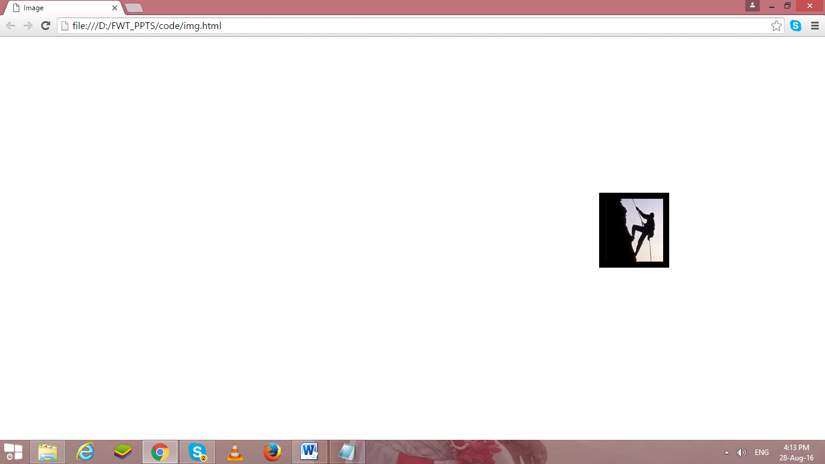

**Its good practice to follow following html format:-**

<!DOCTYPE html>  
<html lang="en-us">  
<head>

<meta charset="utf-8">  
  <title> Title</title>  
</head>  
<body>  
  
</body>  
</html>

**Anchors <a>**

**Types of link:-**

* Absolute (link to website )
* Relative (link to other files in same system(local file link), link to other section of page)
* Internal
* Graphical
* <a> </a>Tag defines a hyperlink
* Attribute is href…
* By default, links will appear as follows in all browsers:
  + An unvisited link is underlined and blue
  + A visited link is underlined and purple
  + An active link is underlined and red
* The **HTML <body> vlink Attribute**is used to specify a color of a visited link in a Document.
* The **HTML <body> alink Attribute** is used to specify the color of an active link in a document.
* The **HTML <body> link Attribute** is used to specify the default color for a unvisited link in a document.

**Target Attribute: -**

* The target attribute specifies where to open the linked document.
* Syntax:-

<a target="_blank|_self|_parent|_top|*framename*">

* **Attribute values:-**

|  |  |
| --- | --- |
| **Value** | **Description** |
| _blank | Opens the linked document in a new window or tab |
| _self | Opens the linked document in the same frame as it was clicked (this is default) |
| _parent | Opens the linked document in the parent frame |
| _top | Opens the linked document in the full body of the window |
| *framename* | Opens the linked document in the named iframe |

<frame src="top.htm" name="top">  
<frameset cols="50%,50%">  
<frame src="left.htm" name="left">  
<frame src="right.htm" name="right">  
</frameset></frameset>

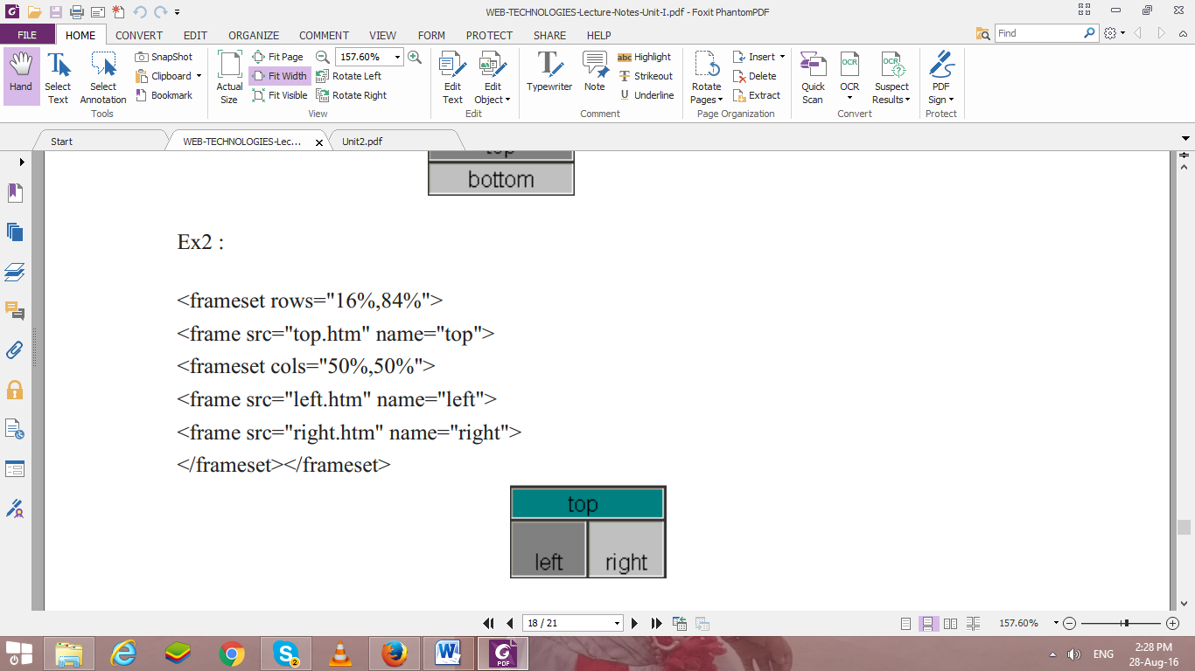

**Tasks To be done**

A.5 Procedure/Task:

Create following table using XHTML tags. Properly align cells, give suitable cell padding and cell spacing, and apply background color, bold and emphasis necessary

Create the following table

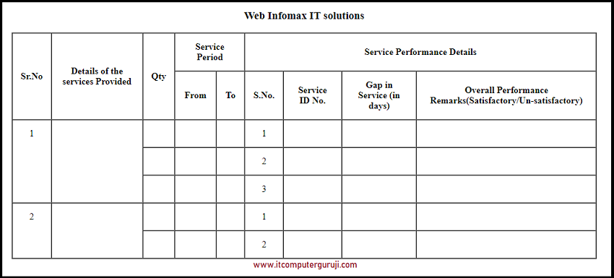

3.Create following nested table

a)

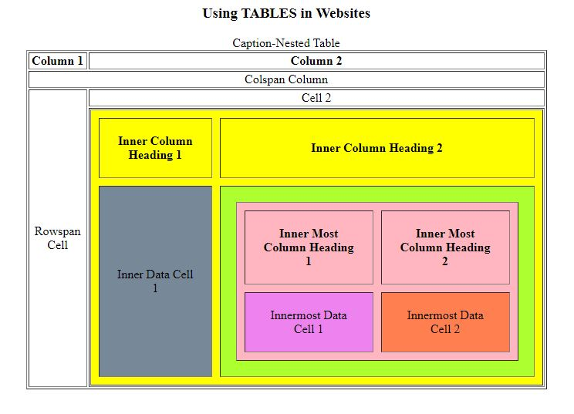

b) Create a table with different types of list in each cell(ordered(with different type), unordered with different type and defination list ), an image in one of the cell, a link in another cell, a clickable images

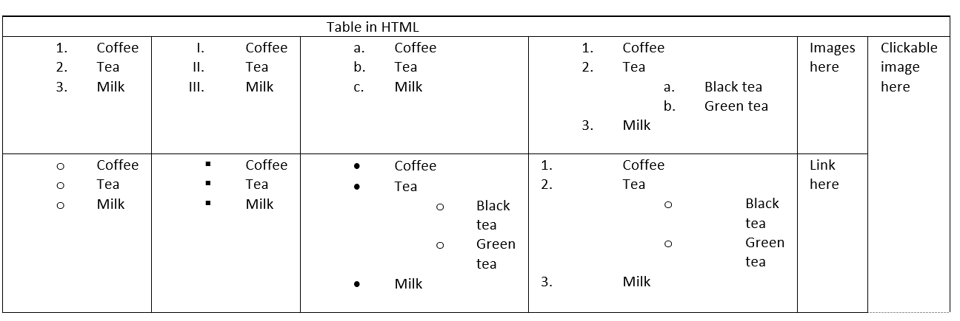

**PART B**

(PART B: TO BE COMPLETED BY STUDENTS)

(Students must submit the soft copy as per following segments within two hours of the practical. The soft copy must be uploaded on the Blackboard or emailed to the concerned lab in charge faculties at the end of the practical in case the there is no Black board access available)

|  |  |
| --- | --- |
| Roll No. : C035 | Name: Sukhada Gulhane |
| Class : B | Batch : B2 |
| Date of Experiment : 21-01-2025 | Date/Time of Submission : 21-01-2025 |
| Grade : |  |

**B.1 Code:**

*(Paste your Code here)*

***Task 1:***

<!DOCTYPE html>

<html lang="en">

<head>

    <meta charset="UTF-8">

    <meta name="viewport" content="width=device-width, initial-scale=1.0">

    <title>Document</title>

</head>

<body>

    <center>

        <table border="2" cellspacing="0px" cellpadding="10px">

            <caption><b>Web Infomax IT solution</b></caption>

            <tr>

                <th rowspan="2">Sr. No</th>

                <th rowspan="2">Details of the services Provided</th>

                <th rowspan="2">Qty</th>

                <th colspan="2">Service Period</th>

                <th colspan="4">Service Perforance Details</th>

            </tr>

            <tr>

                <th>From</th>

                <th>To</th>

                <th>S. No.</th>

                <th>Service ID No.</th>

                <th>Gap in Service (in days)</th>

                <th>Overall Performance Remarks (Satisfactory/Un-satisfactory)</th>

            </tr>

            <tr>

                <td rowspan="3">1</td>

                <td></td>

                <td></td>

                <td></td>

                <td></td>

                <td>1</td>

                <td></td>

                <td></td>

                <td></td>

            </tr>

            <tr>

                <td></td>

                <td></td>

                <td></td>

                <td></td>

                <td>2</td>

                <td></td>

                <td></td>

                <td></td>

            </tr>

            <tr>

                <td></td>

                <td></td>

                <td></td>

                <td></td>

                <td>3</td>

                <td></td>

                <td></td>

                <td></td>

            </tr>

            <tr>

                <td rowspan="2">2</td>

                <td></td>

                <td></td>

                <td></td>

                <td></td>

                <td>1</td>

                <td></td>

                <td></td>

                <td></td>

            </tr>

            <tr>

                <td></td>

                <td></td>

                <td></td>

                <td></td>

                <td>2</td>

                <td></td>

                <td></td>

                <td></td>

            </tr>

        </table>

    </center>

</body>

</html>

***Task 2:***

<!DOCTYPE html>

<html lang="en">

<head>

    <meta charset="UTF-8">

    <meta name="viewport" content="width=device-width, initial-scale=1.0">

    <title>Document</title>

</head>

<body>

    <center>

        <table cellspacing="px" cellpadding="0px" border="1">

            <caption>Caption-Nested Table</caption>

            <tr align="center">

                <th>Column 1</th>

                <th>Column 2</th>

            </tr>

            <tr align="center">

                <td colspan="2">Colspan Column</td>

            </tr>

            <tr align="center">

                <td rowspan="2">Rowspan Cell</td>

                <td>Cell 2</td>

            </tr>

            <tr>

                <td>

                    <table cellspacing="10px" cellpadding="10px" bgcolor="yellow" border="1px yellow">

                        <tr align="center" bgcolor="yellow">

                            <th>Inner Column Heading 1</th>

                            <th>Inner Column Heading 2</th>

                        </tr>

                        <tr align="center">

                            <td bgcolor="#788c9c">Inner Data Cell 1</td>

                            <td bgcolor="#adff30">

                                <table border="2" bgcolor="pink" cellspacing="10px" cellpadding="10px"

                                    border="5px pink">

                                    <tr align="center">

                                        <th>Inner Most Column Heading 1</th>

                                        <th>Inner Most Column Heading 2</th>

                                    </tr>

                                    <tr align="center">

                                        <td bgcolor="violet">Inner Most Data Cell 1</td>

                                        <td bgcolor="tomato">Inner Most Data Cell 2</td>

                                    </tr>

                                </table>

                            </td>

                        </tr>

                    </table>

                </td>

            </tr>

        </table>

    </center>

</body>

</html>

***Task 3:***

<!DOCTYPE html>

<html lang="en">

<head>

    <meta charset="UTF-8">

    <meta name="viewport" content="width=device-width, initial-scale=1.0">

    <title>HTML Table with Lists, Image, and Links</title>

</head>

<body>

    <table border="1" cellpadding="10" cellspacing="0" style="width: 100%; text-align: left;">

        <tbody>

            <tr align="center">

                <th colspan="6">

                    Table in HTML

                </th>

            </tr>

            <tr>

                <td>

                    <ol type="1">

                        <li>Coffee</li>

                        <li>Tea</li>

                        <li>Milk</li>

                    </ol>

                </td>

                <td>

                    <ol type="I">

                        <li>Coffee</li>

                        <li>Tea</li>

                        <li>Milk</li>

                    </ol>

                </td>

                <td>

                    <ol type="a">

                        <li>Coffee</li>

                        <li>Tea</li>

                        <li>Milk</li>

                    </ol>

                </td>

                <td>

                    <ol type="1">

                        <li>Coffee</li>

                        <li>Tea</li>

                        <ol type="a">

                            <li>Black Tea</li>

                            <li>Green Tea</li>

                        </ol>

                        <li>Milk</li>

                    </ol>

                </td>

                <td>

                    <img src="https://img.freepik.com/free-photo/animal-eye-staring-close-up-watch-nature-generative-ai_188544-15471.jpg"

                        alt="Placeholder Image" width="150" height="150">

                </td>

                <td rowspan="2">

                    <a href="https://www.example.com" target="_blank">

                        <img src="https://img.freepik.com/free-photo/adorable-looking-kitten-sleeping_23-2150886246.jpg "

                            alt="Clickable Image" width="150" height="150">

                    </a>

                </td>

            </tr>

            <tr>

                <td>

                    <ul type="circle">

                        <li>Coffee</li>

                        <li>Tea</li>

                        <li>Milk</li>

                    </ul>

                </td>

                <td>

                    <ul type="">

                        <li>Coffee</li>

                        <li>Tea</li>

                        <li>Milk</li>

                    </ul>

                </td>

                <td>

                    <ul type="">

                        <li>Coffee</li>

                        <li>Tea</li>

                        <ul type="circle">

                            <li>Black Tea</li>

                            <li>Green Tea</li>

                        </ul>

                        <li>Milk</li>

                    </ul>

                </td>

                <td>

                    <ol type="1">

                        <li>Coffee</li>

                        <li>Tea</li>

                        <ul type="circle">

                            <li>Black Tea</li>

                            <li>Green Tea</li>

                        </ul>

                        <li>Milk</li>

                    </ol>

                </td>

                <td>

                    <a href="https://www.example.com" target="_blank">Visit Example</a>

                </td>

            </tr>

        </tbody>

    </table>

</body>

</html>

**B.2 Output**

*(Take screen shots of the output at run time and paste it here)*

*Task 1:*

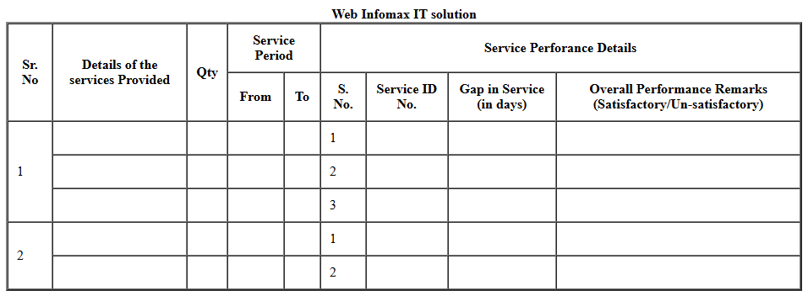

*Task 2:*

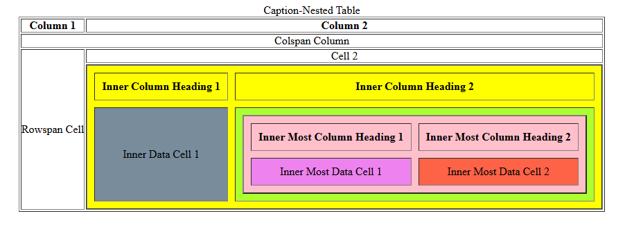

*Task 3:*

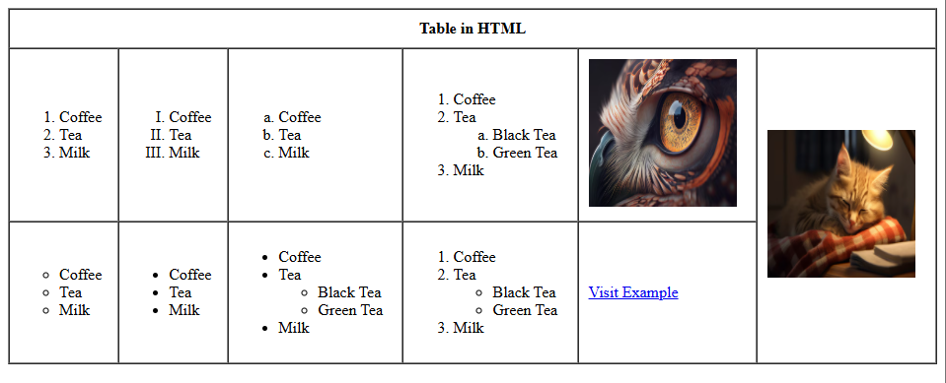

**B.3 Conclusion:**

During this practical, I gained hands-on experience with various HTML tags and their functionalities. I learned how to structure web pages using tables, lists (ordered, unordered, and definition lists), and how to embed images and links effectively. Additionally, I experimented with nested tables and applied attributes like cell padding, spacing, and background colors. The creation of interactive elements like clickable images and links helped me understand how to make a webpage more engaging. I also explored the use of frame elements to structure content and tested different list types within table cells, which was a bit tricky but interesting.

**B.3 Observations and Learning:**

This practical helped me understand the fundamental aspects of HTML, from creating basic structures like tables and lists to incorporating multimedia elements such as images and links. I am now more comfortable with writing HTML code, organizing content efficiently, and applying styling techniques using attributes. The practical experience provided a deeper understanding of the versatility of HTML tags and their attributes in web development.

**B.4 Question of Curiosity**

1. Validate html code of your CV code… using following link…. (validate by direct method )

<https://validator.w3.org/>

Input code to validator: -

<!DOCTYPE html>

<html lang="en">

<head>

    <meta charset="UTF-8">

    <meta name="viewport" content="width=device-width, initial-scale=1.0">

    <title>Document</title>

</head>

<body>

    <center>

        <table border="2" cellspacing="0px" cellpadding="10px">

            <caption><b>Web Infomax IT solution</b></caption>

            <tr>

                <th rowspan="2">Sr. No</th>

                <th rowspan="2">Details of the services Provided</th>

                <th rowspan="2">Qty</th>

                <th colspan="2">Service Period</th>

                <th colspan="4">Service Perforance Details</th>

            </tr>

            <tr>

                <th>From</th>

                <th>To</th>

                <th>S. No.</th>

                <th>Service ID No.</th>

                <th>Gap in Service (in days)</th>

                <th>Overall Performance Remarks (Satisfactory/Un-satisfactory)</th>

            </tr>

            <tr>

                <td rowspan="3">1</td>

                <td></td>

                <td></td>

                <td></td>

                <td></td>

                <td>1</td>

                <td></td>

                <td></td>

                <td></td>

            </tr>

            <tr>

                <td></td>

                <td></td>

                <td></td>

                <td></td>

                <td>2</td>

                <td></td>

                <td></td>

                <td></td>

            </tr>

            <tr>

                <td></td>

                <td></td>

                <td></td>

                <td></td>

                <td>3</td>

                <td></td>

                <td></td>

                <td></td>

            </tr>

            <tr>

                <td rowspan="2">2</td>

                <td></td>

                <td></td>

                <td></td>

                <td></td>

                <td>1</td>

                <td></td>

                <td></td>

                <td></td>

            </tr>

            <tr>

                <td></td>

                <td></td>

                <td></td>

                <td></td>

                <td>2</td>

                <td></td>

                <td></td>

                <td></td>

            </tr>

        </table>

    </center>

</body>

</html>

* Print Screen

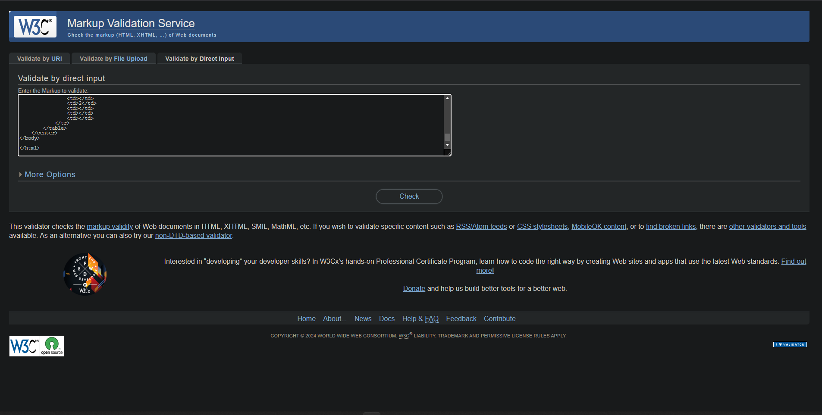

Output of validator: -

* Print Screen

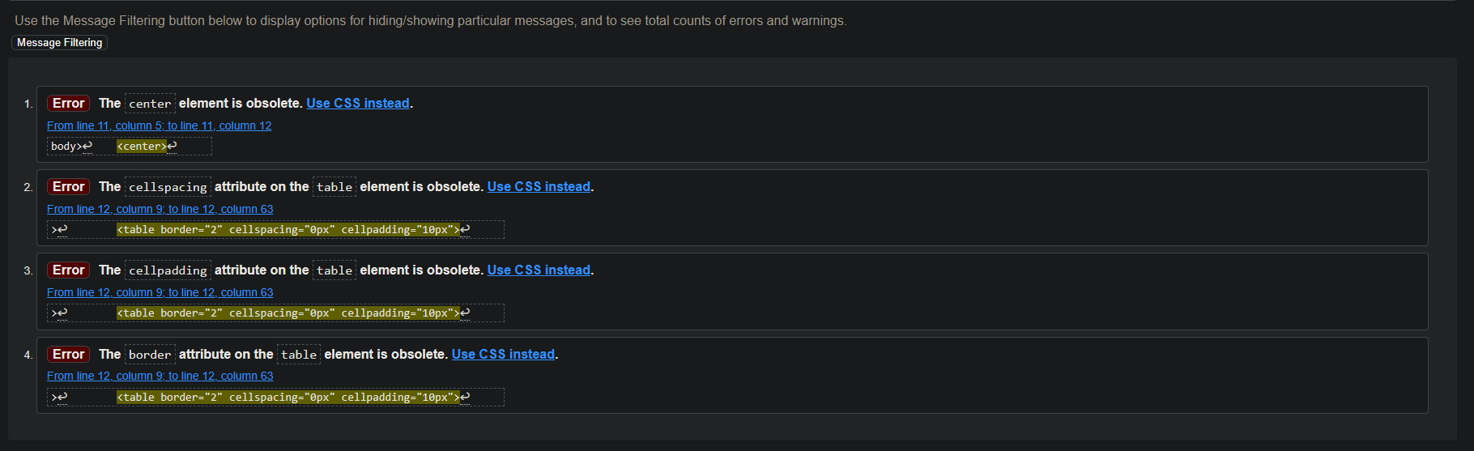

**Conclusion:**

Although elements are deemed as obsolete, the code is logically and structurally sound and produces the expected output